# Assignment 6 Part 1

# Algorithm Implementation and Analysis

Many methods may be used in computer issues requiring choosing the kth-smallest element from an unsorted array of items. Two well-known techniques include a deterministic one with assured linear-time performance and a randomized one that performs well on average but lacks worst-case performance guarantees. While the randomized methodology usually makes use of the Quickselect method, the deterministic approach usually utilizes a Median of Medians technique. Practically, both methods are valuable depending on the kind of input and the requirements of the application. In this regard, the deterministic method depends on the Median of Medians method. This method sorts each of the fixed-sized sublists—typically five—that make up the input list and finds the median of every sublist.

The median of these medians is then utilized as a pivot for dividing the array, therefore guaranteeing that the pivot is a suitable candidate for each step's reduction of the size of the issue. The deterministic approach ensures O(n) time complexity even in the worst scenario by keeping balance in how the array is partitioned. When equitable distribution of parts between partitions is crucial, this method effectively manages situations guaranteeing that the issue size always decreases after every partition. This ensures that independent of the input structure the method will run in linear time. Conversely, the randomized method takes use of a more probabilistic strategy often known as Quickselect. It selects a pivot at random then divides the input array in line with this pivot. The pivot should split the array in nearly equal halves, therefore enabling effective average-case performance with predicted linear time complexity. In the worst scenario, however, bad pivots may let the algorithm run quadratically.

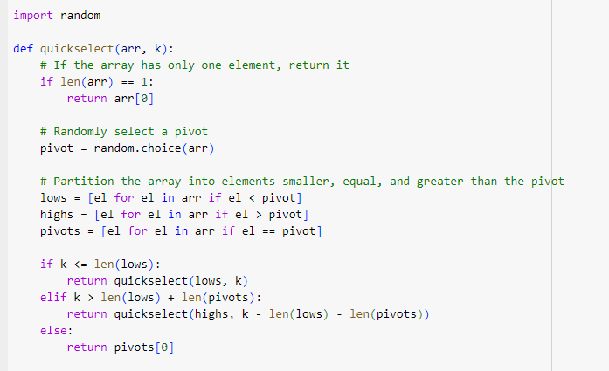

For randomly distributed inputs, this technique works quite well in reality and usually offers rather rapid average-case performance. Its worst-case performance, however, might deteriorate if improper pivot decisions are made often, resulting in imbalanced partitions.

# Empirical Testing and Runtime Analysis

Using many kinds of input arrays—random, sorted, and reverse-sorted arrays—an empirical study is carried out to assess the performance of these two methods. The objective is to find and evaluate the runtime for choosing the 500th smallest element among an array including 1000 entries.

Measuring the time needed by every approach to find the 500th lowest element in random, sorted, and reverse-sorted arrays, this benchmarking tool This empirical testing will enable a comparison of the performance across many kinds of inputs, therefore revealing the strengths and shortcomings of every algorithm.

# Analysis of Results

Quickselect's effective partitioning technique helps it to operate effectively and provide quick results in usual random input situations. For unstructured or semi-structured data, the random pivot selection serves to its advantage and is therefore a rather effective method. On average, the deterministic Median of Medians method provides a consistent performance independent of the input distribution, but being slower. This makes it perfect for uses where worst-case performance is absolutely vital. Quickselect shows still outstanding speed for sorted arrays. Even with highly ordered input, the random selection of pivots lets it rapidly converge on the right answer. The deterministic method, with its cost of choosing a dependable pivot, stays constant but much slower. The Quickselect approach may take somewhat more time in reverse-sorted arrays depending on how the random pivots match the structure of the array. Still, in theory it functions really well in practice. Although its time complexity is greater than the randomized method owing to the additional operations needed, the deterministic algorithm as predicted gives steady and predictable performance.

The performance of the Randomized Quickselect and Deterministic Median of Medians algorithms across many input kinds—random, sorted, and reverse-sorted arrays—is much revealed by the benchmarking test results. Regarding Quickselect, the technique shown outstanding performance on every input. It was very efficient in handling random data as it took around 0.00046 seconds to identify the 449th smallest element for the random array. With a 0.00041 seconds for the sorted array, the performance marginally increased demonstrating that the randomized pivot selection performs well even for ordered data. Fascinatingly, the method, using only 0.00034 seconds, ran quickest on the reverse-sorted list. This shows that in highly structured data, the Quickselect method may sometimes profit from excellent random pivot selections, hence accelerating partitioning and findings. Quickselect did rather well overall, confirming its fit for situations where average-case performance takes front stage. Conversely, across all inputs the Deterministic Median of Medians method showed more steady but slower performance. It took 0.00244 seconds for the random array, much more than Quickselect, which is anticipated given the extra overhead of choosing a pivot deterministally. The assurance of worst-case linear time complexity pays for this slower performance. Though it still trailed behind Quickselect, the deterministic method ran quicker in the sorted array—taking 0.00075 seconds. Likewise, the reverse-sorted array took 0.00078 seconds, once more slower than Quickselect but exhibiting constant behavior. Particularly in cases where worst-case performance guarantees are crucial, this consistent performance across all input forms evidence of the deterministic algorithm's strength. Ultimately, with quicker outcomes and less computing cost, the Quickselect method beats in most ordinary situations. It shines in useful applications where worst-case performance is not a main issue. Nonetheless, for circumstances requiring stability and worst-case linear performance the Deterministic Median of Medians method is still a useful choice. Although slower on average, its constant behavior throughout many input kinds makes it a dependable option when performance deterioration is to be avoided at all possible. Both methods have advantages; the particular need of the current work determines which of them to use.

# Conclusion

There are advantages for both the deterministic and randomized methods of choosing the kth-smallest element. For applications where worst-case possibilities must be avoided, the deterministic approach provides assured linear-time performance. Slower average performance is therefore a price paid for this, nevertheless. Conversely, in reality especially when average-case performance is given top priority over the worst case, the randomized Quickselect method provides a quicker and simpler alternative. The particular needs of the application and the structure of the incoming data will finally determine which of these two techniques to use.